**Photocell**

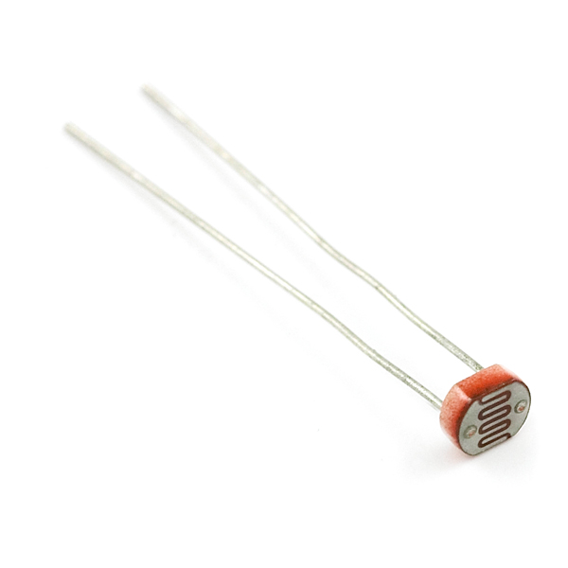

**What It Does**: The photocell produces an electrical voltage in the presence of light. Measuring the voltage can determine how light or dark an area is.

**What It Tells You**: By measuring the voltage from the photocell you can determine how bright the immediate area is. This value can be converted into a physical unit, such as lumens or candles, but we use the raw sensor values in our example. Reading 0 from the sensor will indicate completeness darkness, with higher values as it gets brighter.

**Required Connections**:This circuit for this sensor should already be wired for the workshop and should have three different wires.

Red Wire: power, connect this to **5V** on the Arduino.  
Black Wire: ground, connect this to **GND/Ground** on the Arduino.  
Green/Yellow/Blue: this wire is the signal from the photocell, connect this to an **Analog Input**.

**Using the Photocell in Scratch**:

Use a *value of sensor* block to read in from the selected Analog Input. Adjust the pull down menu in the block to select the proper pin.

E:\My Dropbox\PhD\IDSA Workshop\Images\valueOfBlock.png

Figure 1: Read Data from Analog Input 0

Also, it will be helpful to store the reading into an appropriately named variable.

E:\My Dropbox\PhD\IDSA Workshop\Images\ReadInPhotocell.png

Figure 2: Read Sensor Measurement into a Variable

A reading of 0 on the photocell indicates extreme darkness, and the readings increase with brightness. In the example below we the Arduino will print the message “Bright” or “Dark” depending upon the value. We use the *think* block within the Looks menu to print the message.

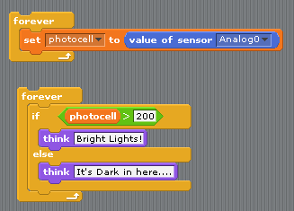

Figure 3: Checking Whether It’s Light or Dark

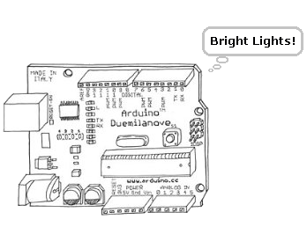

Figure 4: Arduino Responding to a Bright Reading